**Write a problem-solution essay   
about a type of waste**

**Understand**

*What have you learnt about the task?*

**Situation**

We are producing waste faster than ever. What can we do about it? Write a   
problem-solution essay for your school newspaper on a type of waste that you have seen at home, at school or in your neighbourhood, and some ways we can reduce it.

**G.A.P.S.**

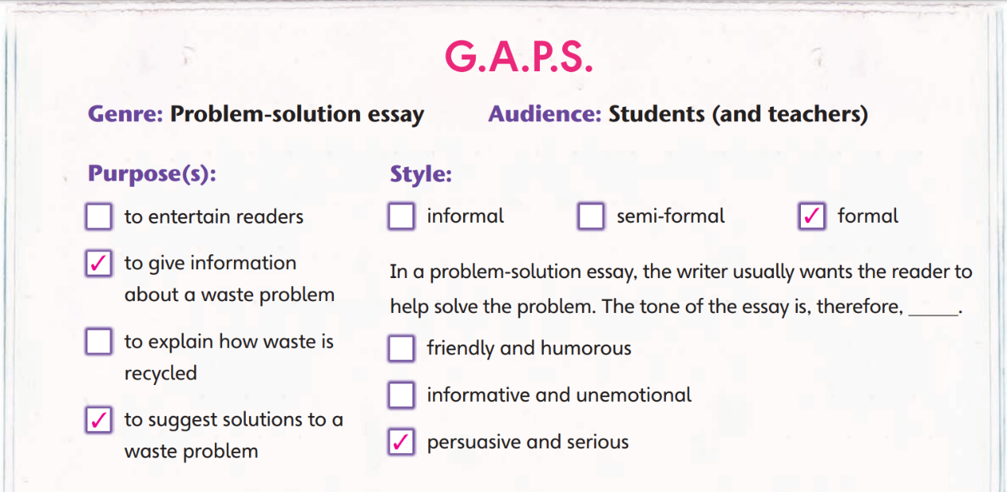

*DOCTOR BLACK. Shutterstock*

**How to organise your writing**

1. Title
   1. Catch the reader's attention
   2. Refer to the main topic
2. Opening paragraph
   1. Introduce the problem in a way that can interest the reader.
   2. Then give more information about the problem.
3. Body
   1. Each paragraph should suggest a solution to the problem.
   2. Each solution should be supported by facts, reasons or examples.
4. Conclusion
   1. Give a summary of the solutions
   2. Persuade the reader to help solve the problem.

**Outline**

*Plan for your writing here. You do NOT need to write in complete sentences. If you are stuck, look at the questions in ‘Tip!’ for ideas.*

**Type of waste to write about:**

What kind(s) of waste do you often see at home, at school or in your neighbourhood? Have you seen people create waste and thought, ‘We could’ve avoided it’?



**A** An eye-catching title related to the main topic:

How can you make the reader interested in your essay? What will the reader want to know about your topic?



**B** Introducing the problem:

How is this type of waste produced? What problems does it cause? Why should the reader be concerned about this?



**C** Solutions to the problem:

**Solution 1**

Supporting reason / fact / example:

What can different parties (e.g. the government, businesses and individuals) do to solve the problem?



Why will this solution work?



**Solution 3**

Supporting reason / fact / example:

**Solution 2**

Supporting reason / fact / example:

**D** Conclusion:

What do you want the reader to remember about the topic? How can they help reduce this type of waste?



**Useful phrases and expressions**

**Problems caused by waste**

affects the health of …

causes respiratory diseases

damages ecosystems

destroys natural habitats

fills landfills with waste

makes land unsuitable for …

puts … in danger

takes a long time to decompose in soil

**Ways to reduce waste**

avoid overbuying

bring one’s own shopping bag / container / cutlery

buy products with less packaging

make compost

persuade schools and businesses to …

recycle and reuse

replace … with reusable products

upcycle waste to make …

**Persuading others to take action**

Do not wait until it is too late to …

If we do not … now, the problem will only get worse.

It is not difficult to …

The grave consequences of … cannot be ignored, so we must …

We can all benefit from …

We need to try harder to …

*You can also look at page 51 of your textbook for useful phrases about:*

è *Describing problems*

è *Proposing solutions*

è *Talking about waste reduction*

è *Linking ideas*

**Writing sheet**

**Name:** ____________________________ **Class:** ________ **Date:** _____________

*Write a problem-solution essay about a type of waste. Build on your outline.*

**D** Conclusion

|  |
| --- |
| **A** An eye-catching title related to the main topic  ______________________________  _______________________________________  Use formal language. Refer to p. 49 of your textbook.  **B** Introducing the problem  _______________________________________  _______________________________________  _______________________________________  _______________________________________  _______________________________________  **C** Solutions to the problem (with supporting reasons, facts or examples)  _______________________________________  _______________________________________  _______________________________________  Use topic sentences and connectives of reason, purpose, result and example.  _______________________________________  _______________________________________  _______________________________________  _______________________________________  _______________________________________  _______________________________________  _______________________________________  _______________________________________  _______________________________________  _______________________________________  _______________________________________  _______________________________________  _______________________________________  _______________________________________ |

**Guided writing sheet**

**Name:** ____________________________ **Class:** ________ **Date:** _____________

*Write a problem-solution essay about a type of waste. Build on your outline.*

**D** Conclusion

|  |
| --- |
| **A** An eye-catching title related to the main topic  ______________________________  _______________ is one of the most _________ issues  Use formal language. Refer to p. 49 of your textbook.  **B** Introducing the problem  we are facing because __________________________  _______________________________________.  Luckily, there are ways to ________________________  _______________________________________.  First of all, _____________________________ so that  **C** Solutions to the problem (with supporting reasons, facts or examples)  _______________________________________.  _______________________________________  Use topic sentences and connectives of reason, purpose, result and example.  _______________________________________  Secondly, _________________________________.  It is actually as ______________ as ______________.  _______________________________________  _______________________________________  Another solution is to ___________________________.  For example, _______________________________.  _______________________________________  _______________________________________  In short, __________________________________.  _______________________________________  If we do not want to ______________________, we must  try harder to _______________________________. |

**Task model**

**Cut out single-use plastic**

Single-use plastic is convenient. It is easier to dispose of plastic plates than to clean reusable ones. However, plastic pollution is one of the most serious environmental problems we have. Luckily, we can do many things to reduce pollution from single-use plastic.

One solution is to avoid using single-use cutlery when eating takeaways. For example, we can use our own utensils and refuse plastic cutlery such as spoons, forks and knives. We can also refuse plastic drinking straws and use reusable metal straws instead. They work as well as plastic ones.

Secondly, it is less wasteful to buy fruits and vegetables from local wet markets than from supermarkets. Produce in local markets has less plastic packaging than in supermarkets. We can reduce plastic waste even more if we bring our own reusable shopping bags.

Finally, at home, we can stop using single-use plastic containers to store leftovers. Reusable glass or metal containers, for instance, are greener and less harmful to health, since plastic can sometimes get into food.

In short, single-use plastic is terrible for the environment. We must, therefore, try harder to stop using it.