**Write an article about a hobby**

**Understand**

*What have you learnt about the task?*

**Situation**

The editor of the school magazine wants you to write an article about your favourite hobby for next month’s issue. Write your article.

**G.A.P.S.**

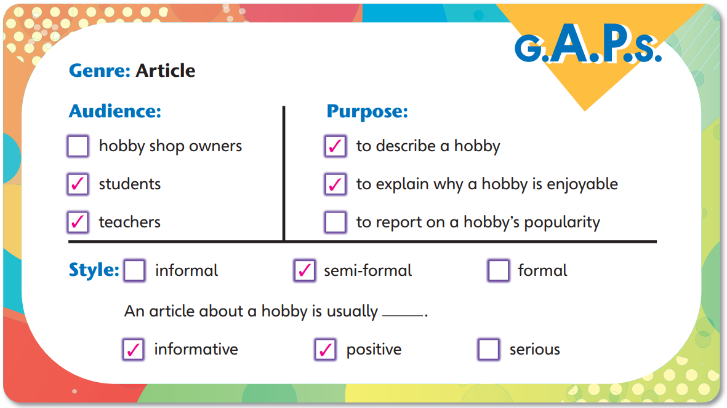

*Choo Studio. Shutterstock*

**How to organise your writing**

1. Use a short, eye-catching title.
2. Introduce the article, e.g. by saying something about the topic of the article and what readers can expect to find out about it.
3. Introduce the hobby.
   1. Use a subheading for each aspect of the hobby.
   2. Give some relevant details for each aspect of the hobby.
4. Give a closing comment, e.g. reason(s) why the activity is a good hobby.

**Outline**

*Plan for your writing here. You do NOT need to write in complete sentences. If you are stuck, look at the questions in ‘Tip!’ for ideas.*

**Hobby to write about:**

What do you like doing in your free time?

Doing a sport? Playing a game? Going somewhere? Reading / Listening to / Collecting something?



**A** A short, eye-catching title:

Refer to p. 49 of your textbook.



**B** Introducing the hobby:

How did the activity become your hobby?

What is an interesting fact about it?

What question can you ask to make a reader curious about it?



**C** Interesting aspects of the hobby that I want to share with the reader:

**Aspect 1**

Subheading:

Why is the hobby fun?

What might the reader want to know about the hobby, e.g. origin / equipment / benefit(s)?



Refer to p. 49 of your textbook.



**Aspect 2**

Subheading:

**D** A closing comment:

How would you encourage the reader to try the hobby?

If the reader wants to know more about the hobby, what can they do?



**Useful phrases and expressions**

**Describing how you developed a hobby**

I developed the habit of … when …

I first got into … because …

I got hooked when I discovered / found out …

I took it up … ago.

The first time I tried … was … At that time, I felt …

**Giving facts about a hobby**

It originated in / It first appeared in [country / place].

It is similar to …

It has recently taken off in [country / place].

It is popular among [group of people].

The trend is spreading to [country / place / group of people].

**How you may benefit from a hobby**

deepen my bonds with friends / family members

develop new skills

improve my ability to …

make me healthier

make new friends

reduce the stress in life

**Encouraging others to try your hobby**

… is easier than you might think.

If you like …, … is for you.

Why not give it a shot?

*You can also look at page 51 of your textbook for useful phrases about:*

è *Describing hobbies*

è *Describing the qualities needed for different hobbies*

è *Describing how a hobby makes you feel*

è *Giving a closing comment*

**Writing sheet**

**Name:** ____________________________ **Class:** ________ **Date:** _____________

*Write an article about a hobby. Build on your outline.*

|  |
| --- |
| **A** A short,  eye-catching title  _______________________________  **B** Introducing the hobby  _______________________________________  _______________________________________  _______________________________________  **C** Interesting aspects of the hobby  _______________________________________  _____________________  Aspect 1  Subheading 1  _______________________________________  _______________________________________  _______________________________________  _______________________________________  _______________________________________  _____________________  Subheading 2  Aspect 2  _______________________________________  _______________________________________  _______________________________________  _______________________________________  _______________________________________  **D** A closing comment  _______________________________________  _______________________________________  _______________________________________  _______________________________________ |

**Guided writing sheet**

**Name:** ____________________________ **Class:** ________ **Date:** _____________

*Write an article about a hobby. Build on your outline.*

|  |
| --- |
| **A** A short,  eye-catching title  ______________________________  **B** Introducing the hobby  My favourite activity is ______________. I first got into it when  _______________________________________.  Now I ___________________________________  **C** Interesting aspects of the hobby  _______________________________________  Wh____________________?  Aspect 1  Subheading 1  One amazing thing about _____________ is that ________  ___________________. When I _______________,  I feel ____________________________________  _______________________________________  _______________________________________  _____________________  Aspect 2  Subheading 2  To _________________ well, you need to __________  ____________________________. To do that, you can  _______________________________________  _______________________________________  _______________________________________  _______________ is a good hobby for people who ______  **D** A closing comment  _____________________________. It has helped me  _______________________________________  _______________________________________ |

**Task model**

**Exploring Hong Kong one step at a time**

Most visitors to Hong Kong expect bright lights and tall buildings. They don’t expect to find some of the best hiking trails in the world. I felt the same way until I joined the school Hiking Club. Now I go hiking with the club every weekend and I love it.

**Best trail in Hong Kong**

Hong Kong has 610 kilometres of hiking trails. The most amazing trail is the newly-opened 65-kilometre long Coastal Trail. Follow this route and you can walk all the way around Hong Kong Island.

**When is the best time to go hiking?**

Autumn is the best time to hike in Hong Kong because the weather is mainly cool and dry.

**Why do I love hiking?**

I love it because I can have fun with friends. I’ve also developed new skills like map reading and first-aid skills.

We live in a beautiful part of the world and hiking is a great way to explore it.